CS 255 System Design Document

UML Diagrams

UML Use Case Diagram
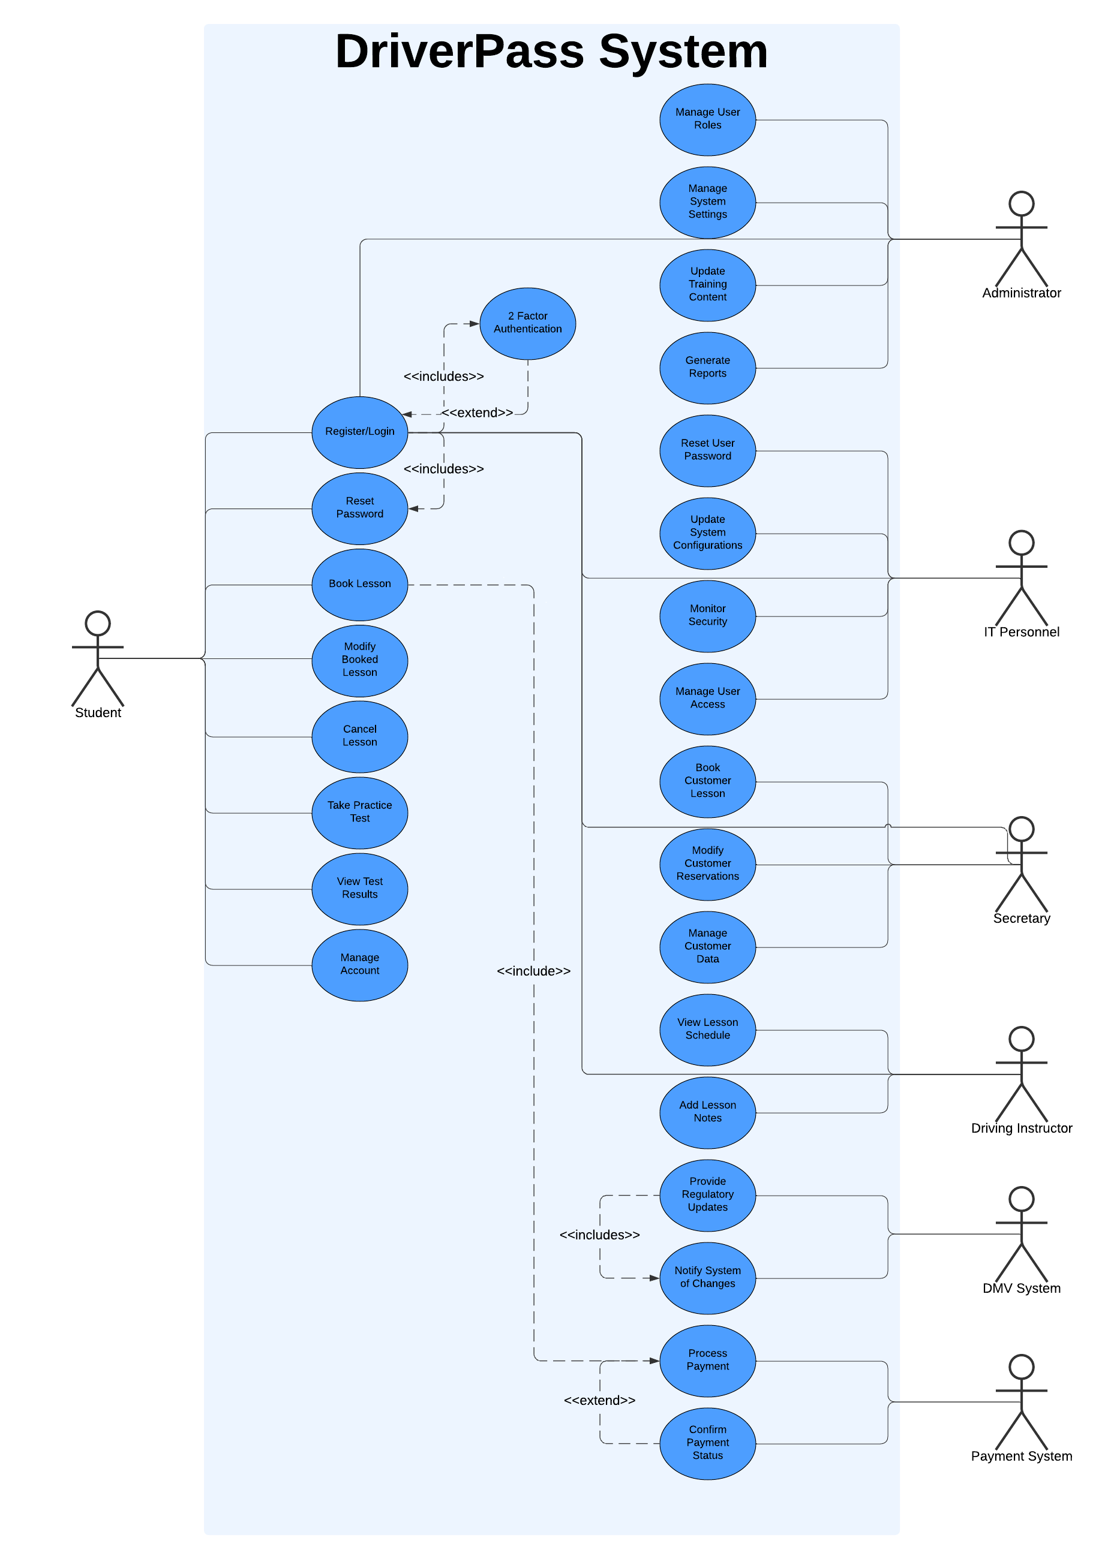

UML Activity Diagrams
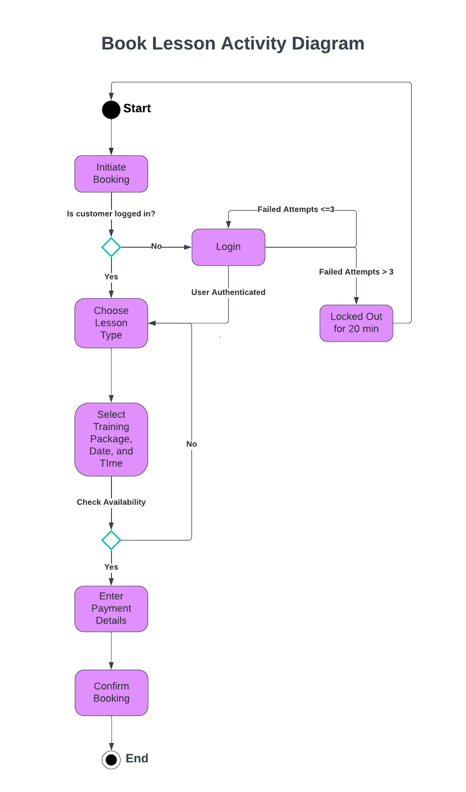

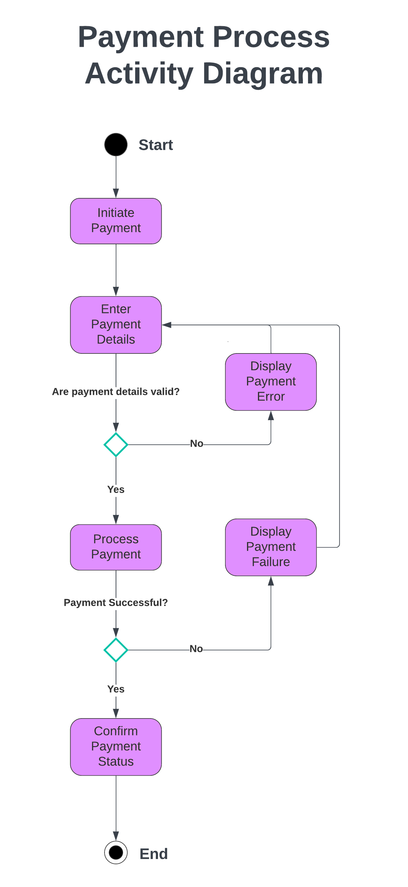

UML Sequence Diagram
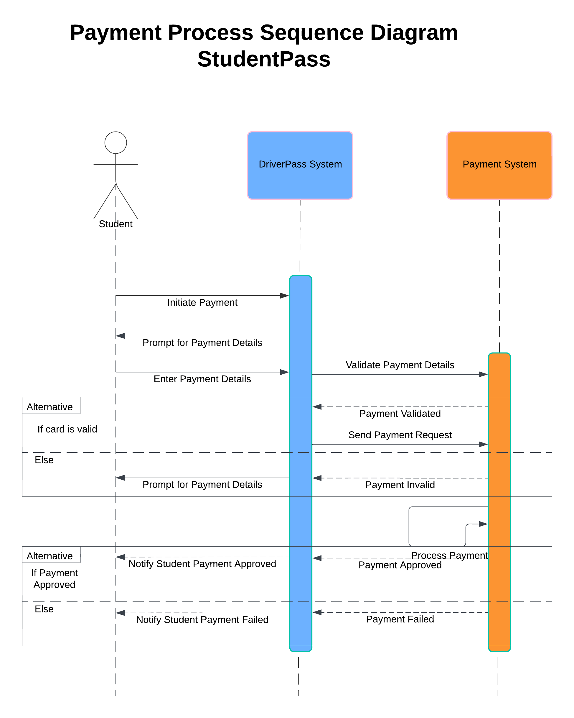

UML Class Diagram
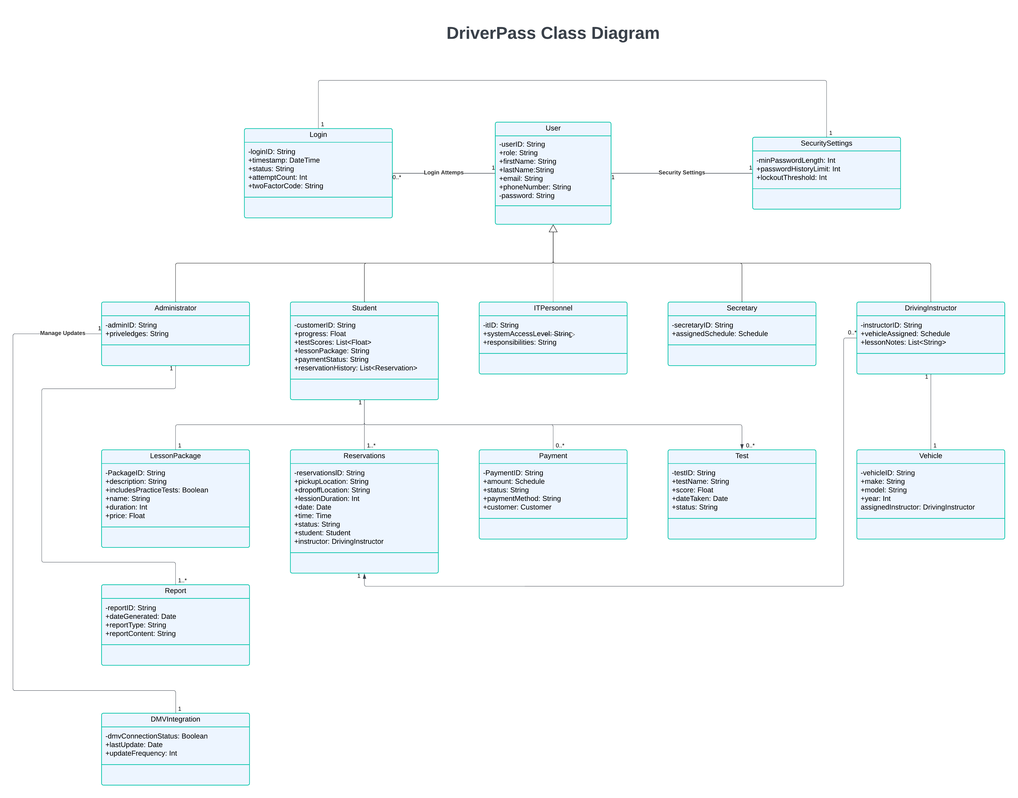

Technical Requirements

Infrastructure Requirements
The DriverPass system requires a reliable cloud-based infrastructure with web servers and load balancing to handle multiple users accessing training materials, scheduling systems, and practice test platforms. The cloud setup ensures we meet the 2-second response time requirement while providing reliable storage for downloadable reports in Excel format and training materials. Built-in redundancy and backup servers ensure high availability and minimal downtime, making the system accessible from any location through both desktop and mobile devices.

Software and Database Requirements
The software needs include a secure database management system to handle different user roles including administrators, IT staff, secretaries, and customers, with each role having specific access permissions. This system will store and manage customer information (names, addresses, phone numbers), training packages (three levels of service from basic to comprehensive), scheduling data for driving lessons and instructors, and practice test results. Integration requirements include real-time connection to the DMV database for rule and requirement updates, a secure payment interface for credit card processing with full encryption, and an email system for password resets, appointment confirmations, and system notifications.

Security and Platform Requirements
For security implementation, we'll need SSL/TLS encryption for data protection and a password system that enforces 12-character minimum passwords with uppercase letters, lowercase letters, numbers, and special characters. The system must include two-factor authentication, login attempt monitoring with a three-strike lockout and 20-minute wait period, and CAPTCHA verification. Following DMV requirements, the user interface needs to work across different platforms including Windows, MacOS, and mobile devices both iOS and Android. It shall also have support for varying screen sizes to ensure accessibility for all users.

Development and Maintenance Requirements
The development tools required include version control for tracking code changes, continuous deployment for immediate updates of DMV requirements and security patches, and testing frameworks to ensure everything works correctly. We'll need monitoring tools to track system performance, detect unauthorized access attempts, verify data synchronization, and monitor payment processing. The backup system will automatically save data with cloud-based recovery options in case of system failures. This comprehensive setup creates a secure and reliable system that meets all the business requirements while allowing for future growth and updates as DMV requirements change.

